Acid bases Practice worksheet
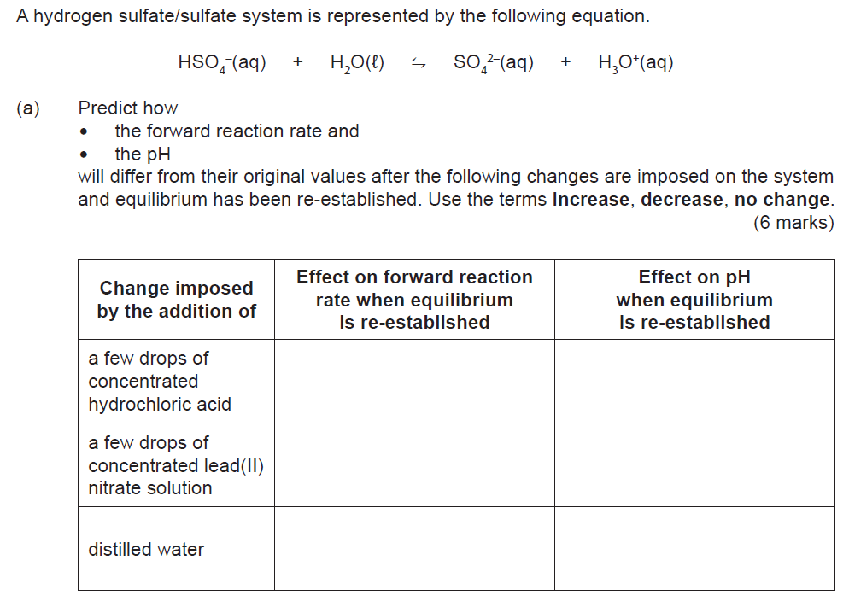
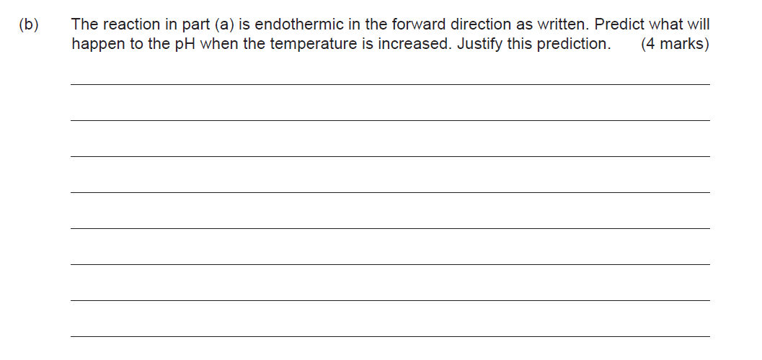
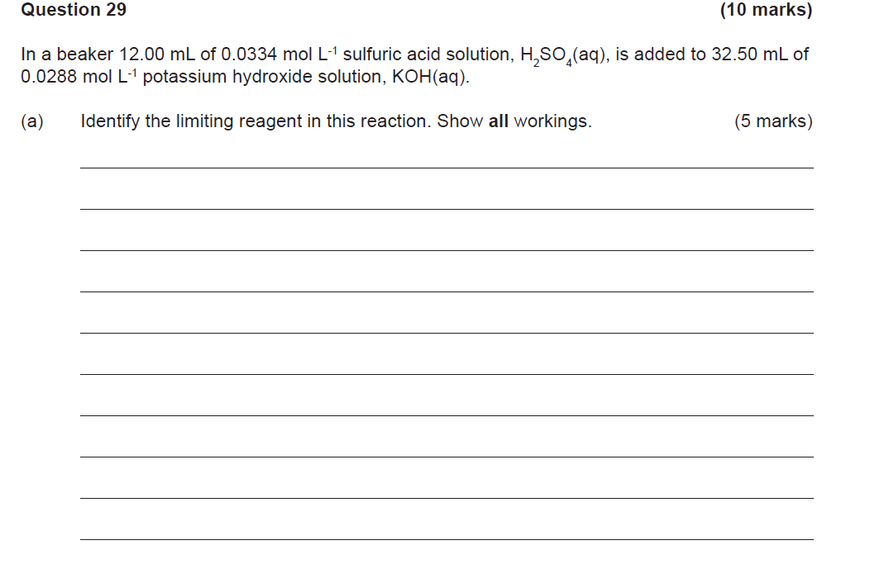
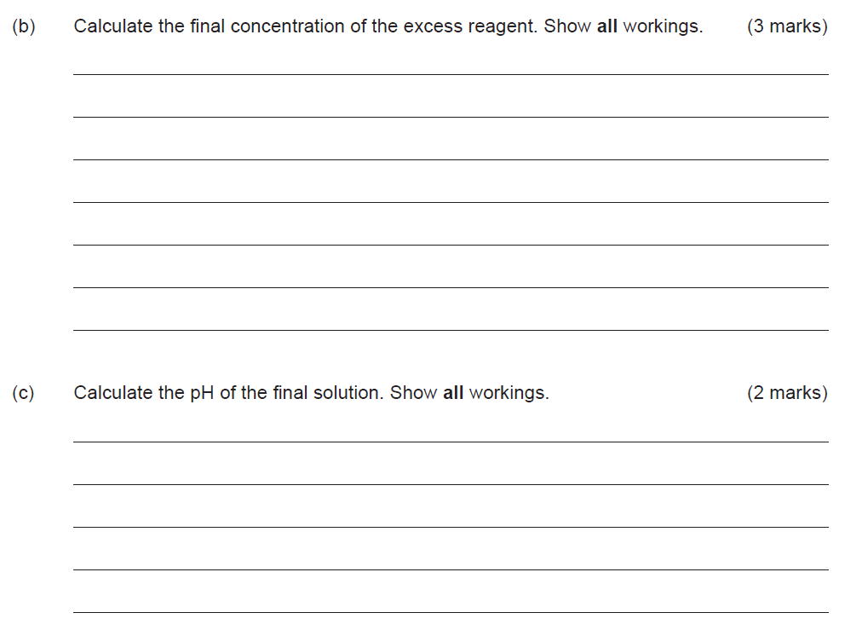
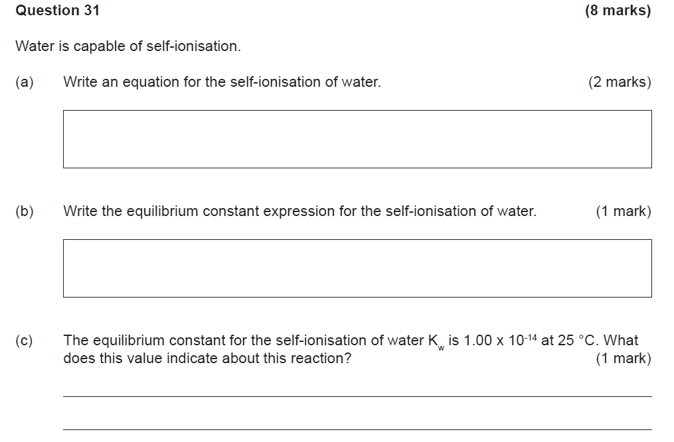
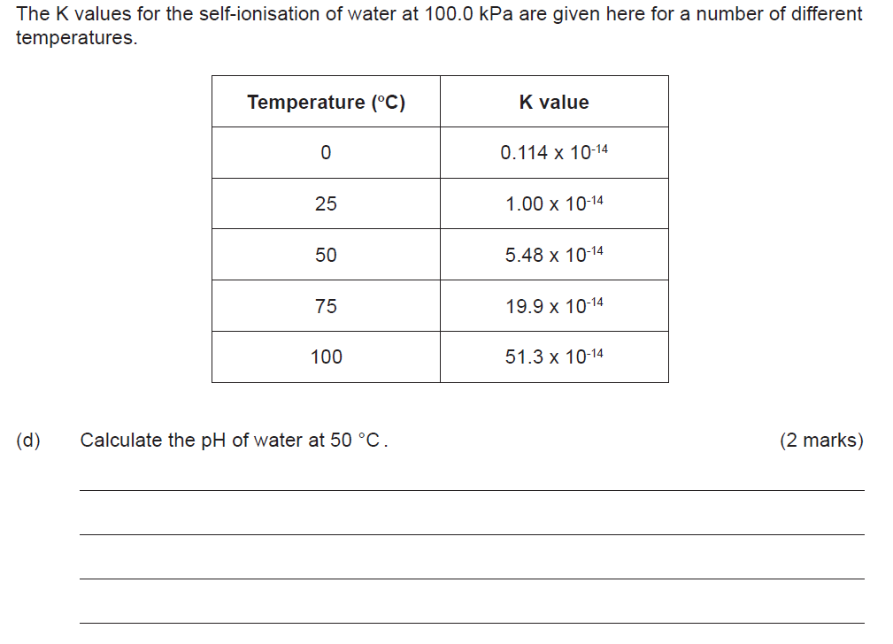
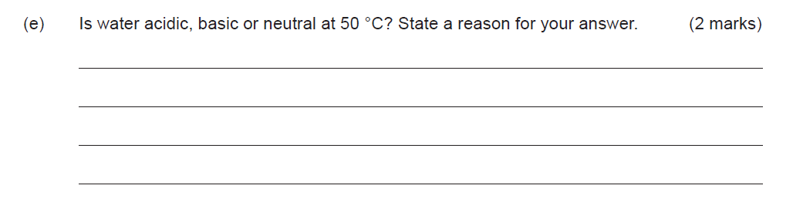
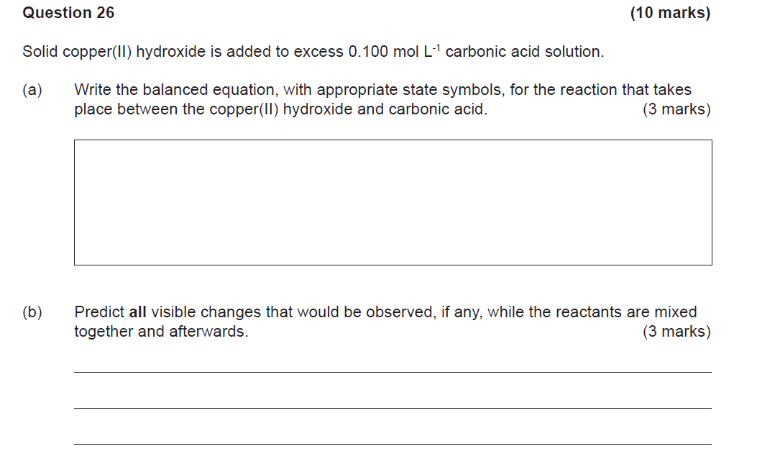
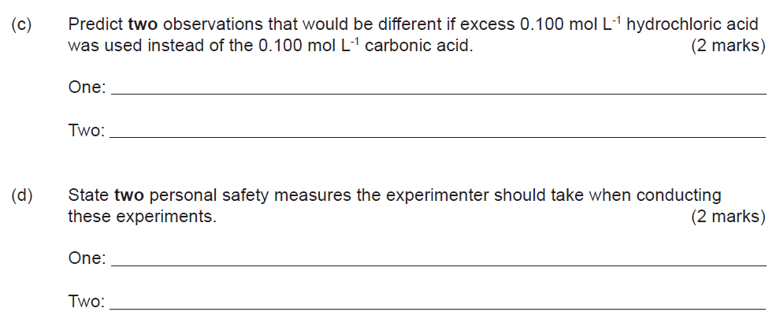
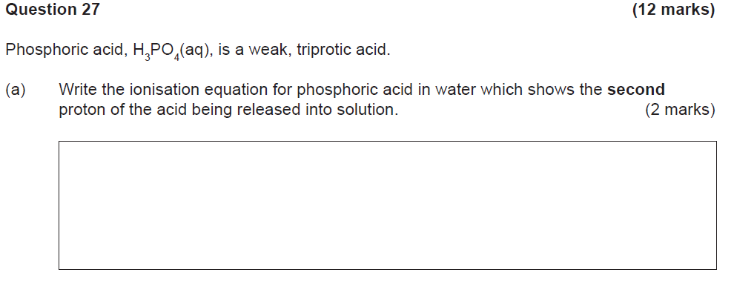
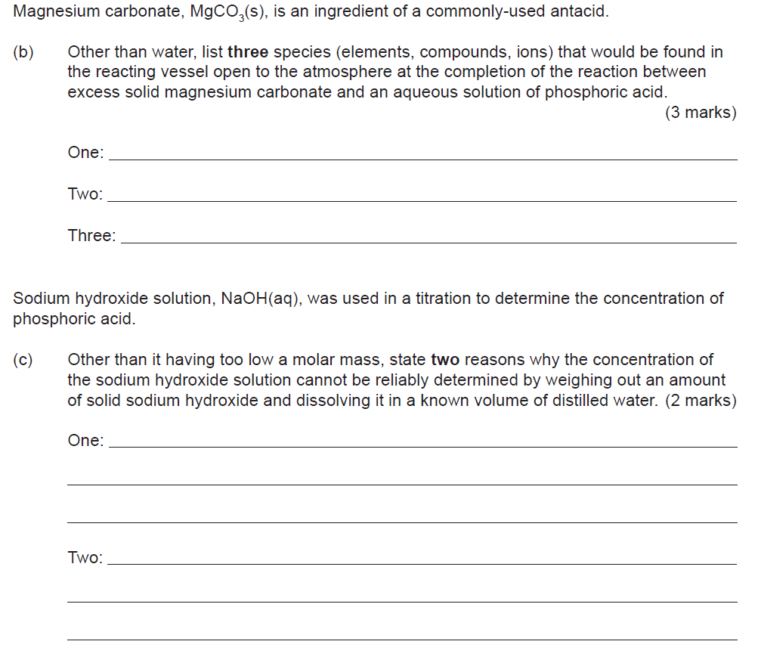
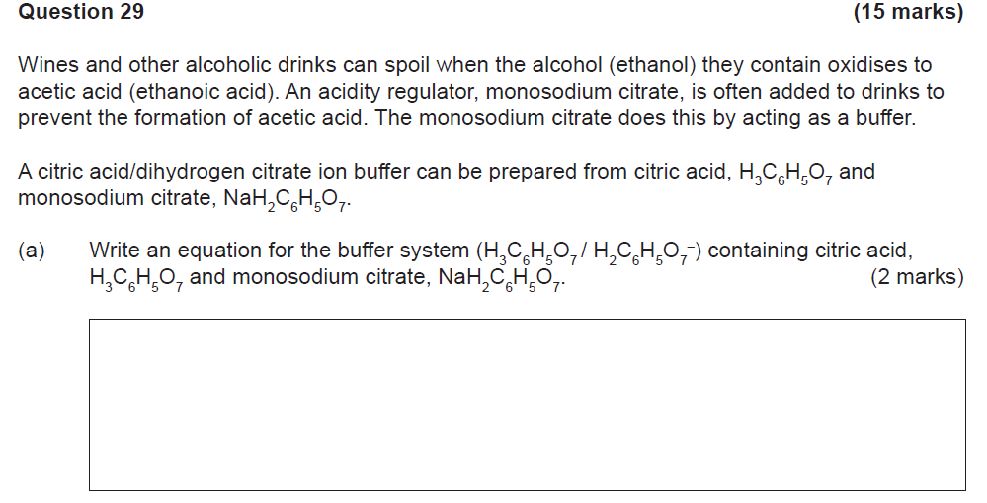
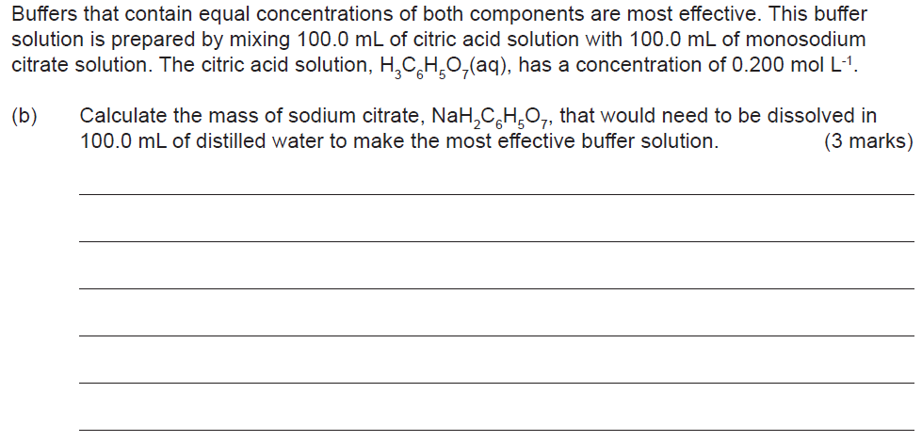
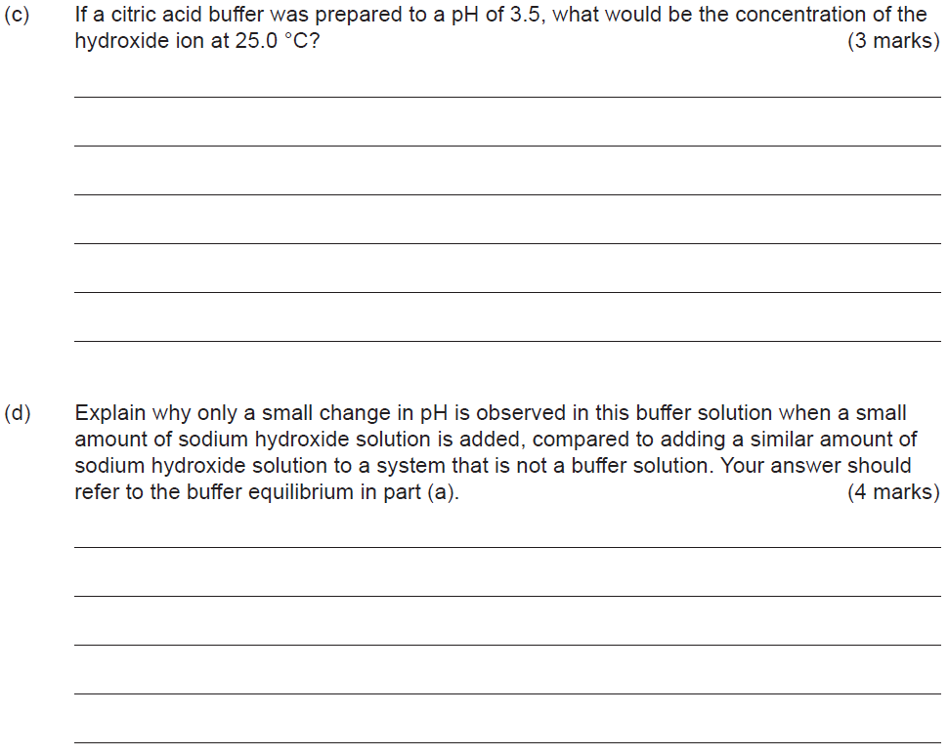
- Consider the following data:

Barbituric acid HC₄H₃N₂O₃ Ka = 9.8 x 10⁻⁴ at 25ºC

If you were to put 2 .0 M of HC₄H₃N₂O₃ into pure distilled water what would:

- The pH of the solution be to 2 significant figures [ 3 marks, -1 for incorrect sig figs ]

- Calculate the percentage ionisation of Barbituric acid, to 2 significant figures [ 2 marks, -1 for incorrect sig figs ]

